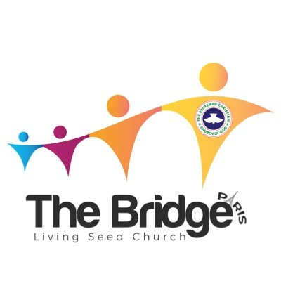
WORKERS RETREAT PROGRAMME 2025
A Season of Refreshing
(We Recharge, Reflect, Reconnect, and Build Together)

- Worship – (SOT)------------------------------------------------------------1hr (10am – 11am)
- Prayer / Charge – (Dr. Iseoluwa)-----------------------------------------1hr (11am – 12pm)
- Prayer / Charge – (Dcn. Gauis)--------------------------------------------1hr (12pm - 1pm)
- Prayer / Charge – (Pst. Shegun)--------------------------------------------1hr(1pm – 2pm)
- Discussions / Games (Sis. Kambili)-----------------------------------------1hr (2pm – 3pm)
- Teaching (Bro. Vincenchi)----------------------------------------45min (3pm – 3:45pm)
- Closing Prayers (Any Worker)------------------------------------10min (3:45pm – 3:55pm)

